

Inter Sources Inc.

Work Force Analytics

Business Requirements Document

**Prepared by:** Raj

**Prepared for:**

**Date Submitted:** Sep 18th 2014

**Project Sponsor: Ankit Shah**

**Version:** 0.1

**Last Updated:** Sep 18th 2014

**Creation Date:** Sep 18th 2014

Table of Contents

1. Introduction 3

1.1. Document Purpose 3

1.2. Intended Audience 3

1.3. Business Justification 3

1.4 Dependencies on existing systems 4

1.5 Assumptions 4

2. Functional Requirements 5

2.2) First Tab: Head count Tab 5

2.2) Second Tab: Head count Tab 6

2.3) Third Tab: Internal Talent Search 6

2.4) Fourth Tab: Trends 7

# Introduction

## Document Purpose

The purpose of this document is to describe business requirements of Workforce Analytics project

## Intended Audience

The intended audience are the developers, quality assurance engineers who will develop, test and maintain this software application

Mention here briefly if these business requirements are as a result of any previous meetings, correspondence, legislations etc.

## Business Justification

As worldwide economic and political conditions continue to concern business leaders, their attention turns to the various levers that can foster success in uncertain times. Employee salaries make up close to half of many organizations’ operating expenses and can be even higher in some industries such as financial services, so the contribution of the workforce to organization success is perhaps the most important lever to competitive advantage. In fact, the challenge of containing costs while developing a high performing workforce is a primary challenge facing most companies today. But, do organizations know enough about their workforce to optimize the workforce lever?

We all know the US workforce is aging, with the number of people 55 and older holding jobs hitting a record 28 million in 2010. At the same time, the portion of people ages 16-24 in the labor market was at the lowest level since the government began tracking in 1948, falling from 66% in 2000 to 55%, just 17 million of the overall employment base1. Leaving aside the obvious issue of where we get replacement workers for the retiring workforce, these two employee cohorts are quite different. The ways organizations will hire and retain these workers going forward must be different as well. Retaining older workers requires retention programs that include part-time or project-based work. Hiring Gen-Xers and Gen-Yers requires new approaches and retention programs that must provide them with career development and choices about where, when and even how long to work each day. The older cohort is not yet as enamored with emerging social technologies that are becoming the primary means of communication and collaboration for the younger workforce. The older cohort has a wealth of priceless intellectual capital that organizations cannot afford to lose. The younger group offers innovative and creative ideas that are essential to navigate today’s technologies and economic challenges and we must understand how best to tap their contributions. But, do organizations even know, at a glance, how their workforce is comprised?

Organizations struggle to understand their complex existing and potential workforce and how to use each effectively. Which applicants should they recruit? Which of their hires do they wish to retain for their performance and productivity? Who amongst their internal talent do they wish to groom for career advancement? What are the most effective compensation, benefits and development options that will optimize the organization’s competitiveness in the marketplace? As we navigate today’s dynamic economy, do we need to retrench again or pursue growth? We want answers to these questions almost on a daily basis, in addition to the most obvious one: what is our headcount?

Fortunately, it is now possible for organizations to excel at answering workforce-related questions using workforce analytics. We can know whether to bolster training programs, tweak our benefits and compensation plans, or hire into or terminate from key talent pools. We need not turn to across-the-board cost cutting measures and reductions in staff and services. We can sift through far more data and crunch many more numbers to determine who is performing well, who will be needed, where will they be needed, with what skills, and at what cost? We can look at which individuals are achieving their performance goals and see which of them have the competencies needed for today and tomorrow to build a competitive workforce. With breakdowns in place of competencies and of skills needed for the future, along with performance metrics, organizations can thoughtfully manage their workforce with targeted training, development and retention programs, see the value this support delivers, and even make predictions on future performance or retention. Workforce analytics enables not only a view of the workforce today but offers true insights that can drive talent-related decisions and actions, resulting in improved performance in the future.

According to research by MIT and IBM, top-performing companies are three times more likely than lower performers to be sophisticated users of analytics2. These early adopters of workforce analytics simply outperform. Organizations at the highest levels of talent analytics practice, including the adoption of workforce analytics, have 8% higher sales growth, 24% higher net operating income growth, and 58% higher sales per employee.3

Today, organizations can drive financial return on human capital investment and improve the value the workforce delivers to organizational performance through the use of workforce analytics. This paper discusses Oracle’s comprehensive HR Analytics offering and shows how the increased power of metrics and analytic insight can align core workforce business processes with organizational goals and strategies, and help ensure that organizations make the right business decisions today for the future.

## 1.4 Dependencies on existing systems

This software is stand alone and does not have dependency on any other system / applications

Describe the dependencies between this Application (for which these Business Requirements are written) and other existing systems.

List here all the external reference documentation, hyperlinks to web pages etc. that are directly related to these Business Requirements.

## Assumptions

Following assumptions are made while designing the system:

* Data for the application is available through multiple backend systems. This application will not trigger any logic to gather data
* User logging into the system will be having either a role of HR Manager or business analyst

Describe major assumptions that were made (or exist) for these Business Requirements.

List the use cases/business functions that are **in scope**. Mention the name and a brief 2-3 lines short description for each use case/business function that is in scope.

List the system/organizational interfaces that are **in scope**. Mention the name and a brief 2-3 lines short description for each interface that is in scope.

List the use cases/business functions that are **out of scope**. Mention the name and a brief 2-3 lines short description for each use case/business function that is out of scope.

List the system/organizational interfaces that are **out of scope**. Mention the name and a brief 2-3 lines short description for each interface that is out of scope.

# Functional Requirements

The application will consist for 4 Tabs namely

1. **Dashboard**
2. **Headcount Charts**
3. **Internal Talent Search**
4. **Trends**

## 2.2) First Tab: Head count Tab

This will be the home tab where user will land after logging in This tab will have all the overview of workforce distribution as shown in different charts below

Screenshot:

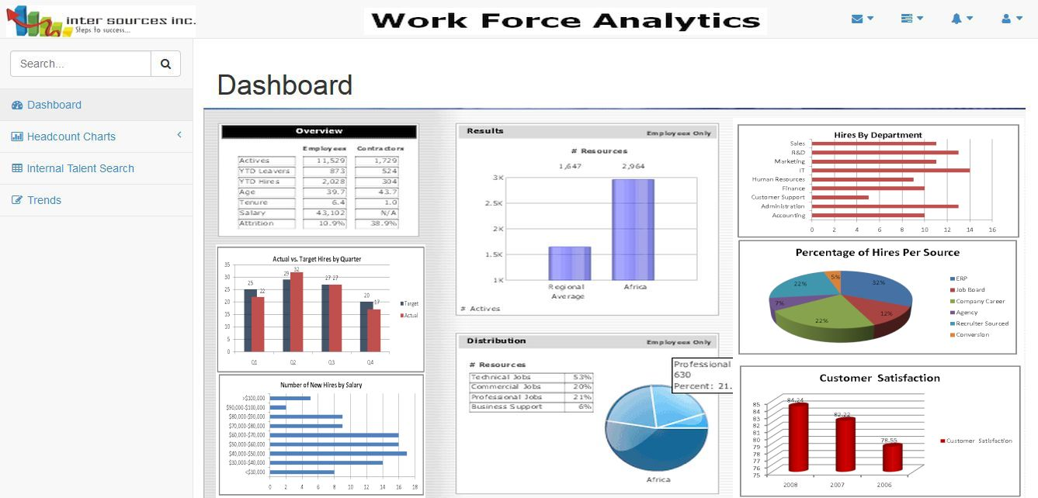

## 2.2) Second Tab: Head count Tab

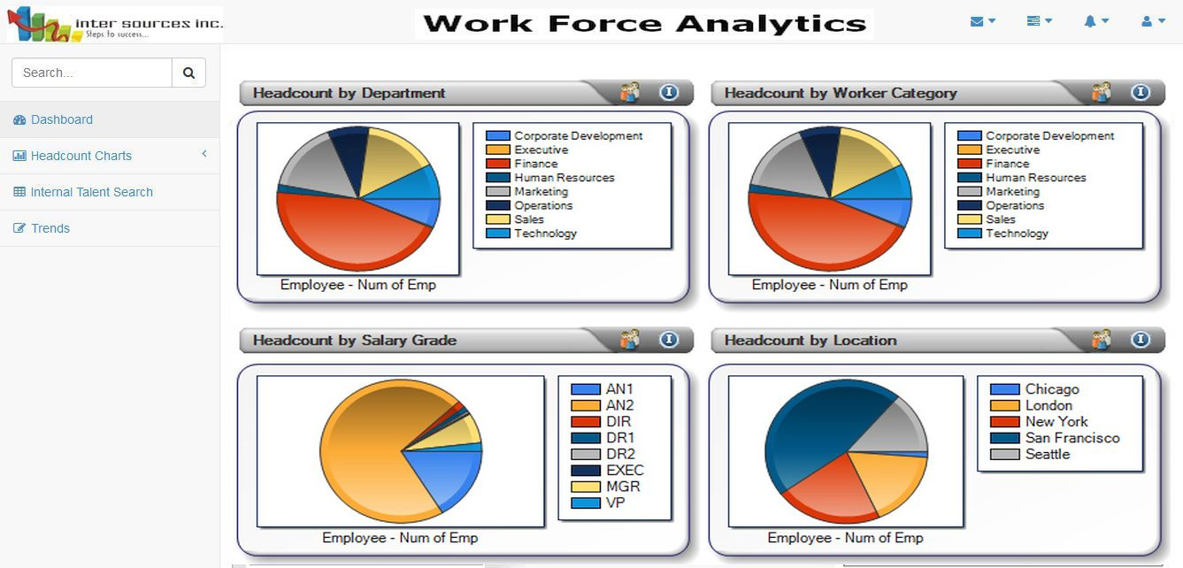

## 2.3) Third Tab: Internal Talent Search

*The HR Manager can do a search for resources within the company by specific skill set or experience level at this tab*

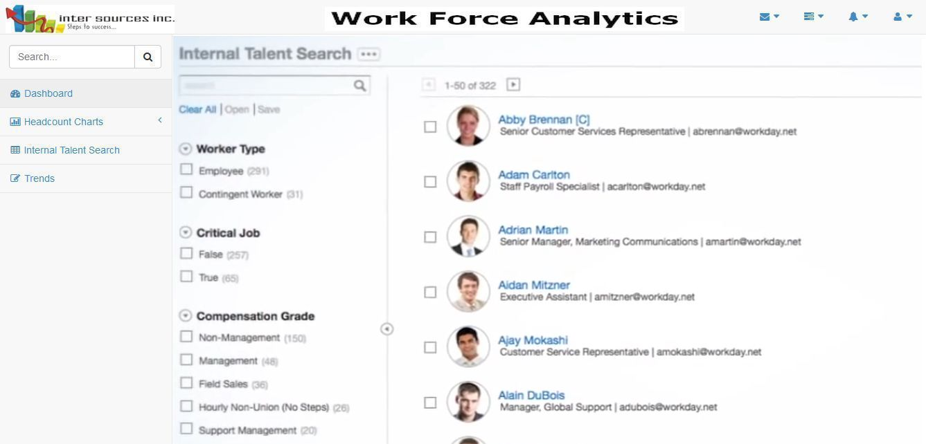

## 2.4) Fourth Tab: Trends

In this tab a HR Manager can see the trends of hiring, voluntary and involuntary attrition trend under any technical / functional manager

